Convert previous Keil projects to version 5.38a

1) Open Options for Target, select Target tab, change to compiler V6.19

2) Open Options for Target, select C/C++ tab, set optimization to O0 (if you don’t it will toss a lot of your code because it thinks it doesn’t do anything); set warnings however you wish; some the ST7735R code needs char to be unsigned (your choice); and remove the Misc controls **-c99**.

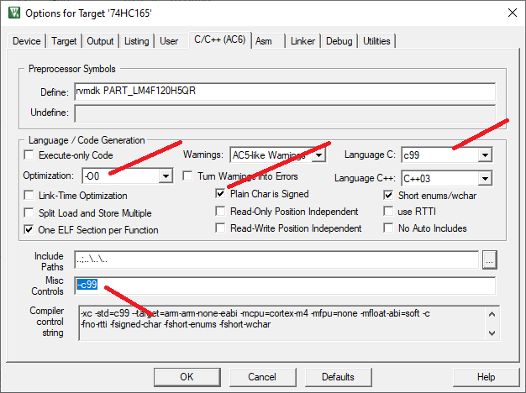

This is how I like it

3) Inline assembly needs to be converted to compiler 6 format For example

**void parrotdelay(uint32_t ulCount){**

**__asm(**

**"ll: subs r0, #1\n"**

**"bne ll\n"**

**);**

**}**